# QNA Covid Chatbot

## Problem Statement

## With the spread of COVID-19 across the world, there is a sense of panic and uncertainty amongst the public. People are not sure what measures to take to safeguard themselves and their family and have many questions. Moreover, rumors, myths and misinformation about COVID-19 have spread as quickly as the virus itself. Public health hotlines and patient communication systems are now dealing with many more inquiries than normal, putting a strain on existing resources. There is a need for health organizations to automate as many responses to these inquiries as possible to free up human resources to deal with more complex problems in the fight against this pandemic.

Our project suggesting that by deploying a simple QnA Maker Bot on your public facing websites you can potentially reduce these volumes while ensuring accurate information is being shared with the citizens.

Standard FAQ websites are a great start, but it can sometimes be difficult for a person to find the information that they need. Even standard web site search boxes are inefficient. By using a bot backed with AI citizens will more quickly find the relevant information they require.

**Industry:** Health

**Project Title*:** QNA Covid Chatbot

**Problem Statement/Opportunity*:**

**Project Description*:**

A chatbot can be a simple and easy way to answer your user questions—and we know they may have a lot right now.

COVID-19 has become a viral topic in the world in recent months. Today, as COVID-19 is strongly showing, that prevention is better than cure. Most of them could realize this phrase very well with the current situation. Yes, People are trying to prevent themselves from others to stop spreading the virus.

**Languages:** HTML, CSS

**Primary Azure Technology*:** QNA MAKER & VISUAL SUDIO CODE

**Output:**

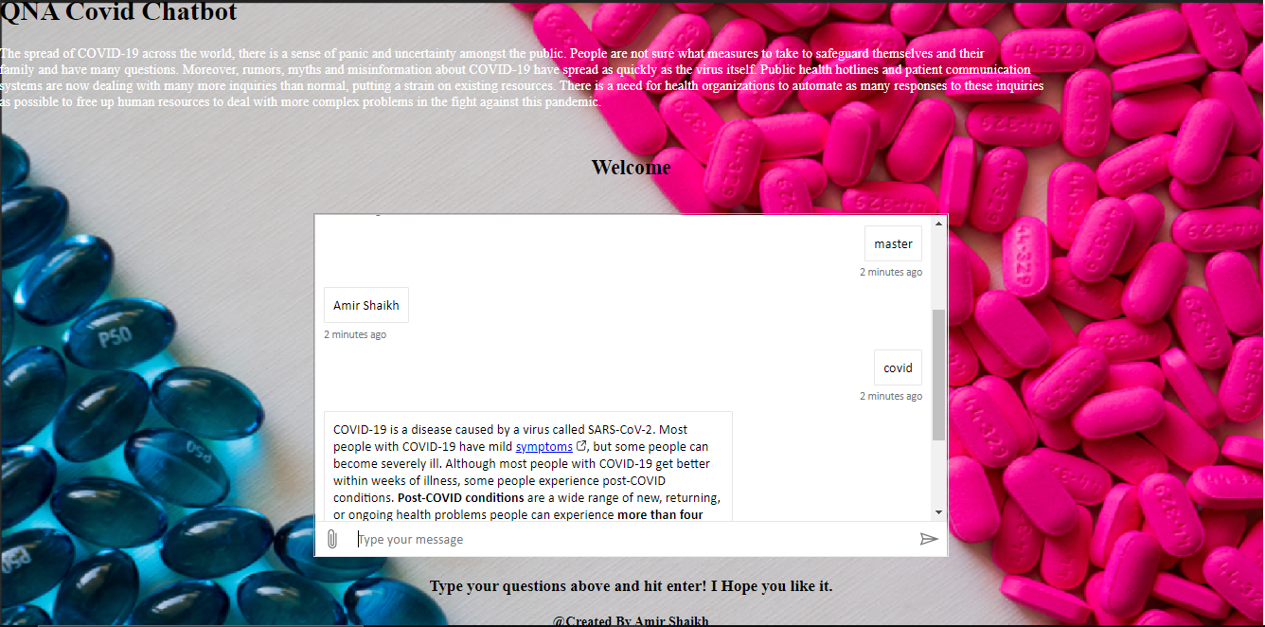

**Html Code:**

<!DOCTYPE html>

<html>

<head>

<meta charset='utf-8'>

<meta http-equiv='X-UA-Compatible' content='IE=edge'>

<title>Qna Chatbot</title>

<meta name='viewport' content='width=device-width, initial-scale=1'>

<link rel='stylesheet' type='text/css' media='screen' href='main.css'>

<script src='main.js'></script>

</head>

<body>

<div style="background-image: url('corona1920.png');">

<h1>QNA Covid Chatbot </h1>

<p style="color: rgb(255, 255, 255);">The spread of COVID-19 across the world, there is a sense of panic and uncertainty amongst the public.

People are not sure what measures to take to safeguard themselves and their <br>

family and have many questions. Moreover, rumors, myths and misinformation about COVID-19 have spread as quickly as the virus itself.

Public health hotlines and patient communication<br>systems are now dealing with many more inquiries than normal, putting a strain on existing resources.

There is a need for health organizations to automate as many responses to these inquiries <br> as possible to free up human resources to deal with more complex problems in the fight against this pandemic.

</p>

<br>

<h2><center>Welcome</center></h2>

<br>

<center>

<iframe src='https://webchat.botframework.com/embed/qnabotcovid1920-bot?s=tmnIJcvFueo.gow_d-N-KZBBwfRXnnsjKnHn5kzFpNjVmSEAZK5-vlQ'

style = 'min-width: 200px; width: 50%; min-height: 400px;'></iframe>

</center>

<center>

<h3 style="color:rgb(0, 0, 0);">

Type your questions above and hit enter! I Hope you like it.

</h3>

<h4 style="color:black;">@Created By Amir Shaikh</h4>

</center>

</div>

</body>

</html>